A G E N D A
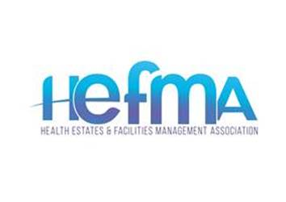
NORTH WEST BRANCH

CHAIR
Cliff Howell
Director of Estates & Facilities (Acting)
Lancashire Teaching Hospitals NHS Foundation Trust
Royal Preston Hospital
Sharoe Green Lane
Fulwood
Preston PR2 9HT
Mobile: 07702 142030
e-mail : cliff.howell@lthtr.nhs.uk

DEPUTY CHAIR
John Fairhurst
Director of Estates & Facilities
Wrightington, Wigan & Leigh NHS Trust
Royal Albert Edward Infirmary
Wigan Lane
Wigan
Lancashire WN1 2NN
Mobile: 07464647918
e-mail: john.fairhurst@wwl.nhs.uk

TREASURER
Bernard Flanagan
Head of Estates & Facilities
The Christie NHS Foundation Trust
Wilmslow Road
Manchester M204BX
Tel: 0161 9187437
e-mail: bernard.flanagan@nhs.net

BRANCH SECRETARY
Currently vacant
e-mail: lesley.watson@lthtr.nhs.uk

IMMEDIATE PAST CHAIR
Chris Murphy
Deputy Director of Facilities
Estates and Facilities Division
Oxford Road Campus
Oxford Road
MANCHESTER
M13 9WL
Telephone: 0161 701 4674
Mobile: 07739392562
Email: chris.murphy@mft.nhs.uk

Visit the Hefma Web Site at www.hefma.org.uk
North West Knowledge Day 2023

Friday 17 November 2023 09.15 – 16.00

Wrightington Hotel, Moss Lane, Wigan, WN6 9PB.

9.15 – 09.30 BRANCH BUSINESS (15 mins)

1. Forum 2024 update Chair

2. Social Media update Chair

3. MyMind offer Chair

4. AOB All

________________________________________________________

09.30 – 10.30 National Strategy & Workstreams update

Kay Mulcahy, HEFMA National Chair

Kay will update the branch on the latest developments of the HEFMA Strategy

and progress with the 4 workstreams.

COMFORT BREAK (15 mins)

10.45 – 11.15 Pensions update by Graham Crossley & Jack Needham
from MediFintech

Graham is considered to be an NHS Pension expert who has appeared on the
Martin Lewis Money Programme on ITV; he will provide an update on the latest
developments on the NHS Pension including the Remedy period and partial
retirement options.

11.15 – 11.45 QUIQ SOLUTIONS Ltd

PAM Assurance Tool demonstration – sponsor presentation

An effective solution for managing your Premises Assurance Model

11.45 – 12.15 Mike Kenny from The Innovation Agency

(Soon to be re-branded as Health Innovation Networks)

Estates and Sustainability Innovation Horizon Scanning and Adoption and

Spread.

LUNCH & NETWORKING (60 mins)

13.15 – 14.00 Ann Cojeen - Hempsons Solicitors – sponsor presentation

Maximising the NHS estate – barriers and enablers from a legal perspective

Ann’s presentation will cover recent experiences acting for Trusts by addressing
the following topics:

- Improving the EV infrastructure at hospitals
- Dealing with telecommunications notices from telecoms operators under
the 2017 Electronic Communications Code
- Covering the cost of pre-planned maintenance and emergency repairs in light of recent issues with RAAC
Ann Cojeen

Ann Cojeen is a real estate solicitor and partner at Hempsons’ Manchester office. She first joined Hempsons in 2002 and acted for trusts and PCTs on all aspects of commercial property including disposals, LIFT, leases, and estates management. She joined Pinsent Masons in 2015 where she advised Homes England and some housebuilders on residential redevelopment before getting back into the health and social care sector and acting for trusts and care home developers at Browne Jacobson. Last year, Ann was persuaded back to Hempsons and so she feels like she has come full circle, acting almost exclusively for the NHS, both for trusts and ICBs.

14.00 – 14.15 Soft FM Compliance – Chris Murphy

Chris will provide an overview on his proposals for the HEFMA NW branch Soft FM compliance sub-group.

COMFORT BREAK (10 mins)

14:25 – 14:40 Greenmount Projects – Headline sponsor presentation

Greenmount Projects are a Northwest based design, construction, and refurbishment contractor.

Mike Sharkey is the Managing Director of Greenmount Projects and has sponsored today’s HEFMA event. Mike will be joined by his colleague Leanne Westcott; they will be providing an overview of the company.

Greenmount’s aim is to be the first choice for Healthcare Design solutions, construction related services, by consistently delivering high quality outcomes in a safe, collaborative, and professional manner within the NHS and various other industries where they are already Partners of Choice.

14:40 -16.00 Guest Speaker Shaun Wane, current England Rugby League Head Coach

Shaun is one of the most successful and decorated coaches in Rugby League, having won every trophy available with Wigan Warriors. He is now Head Coach of England Rugby League; he uses this experience and translates it into the world of management and business leadership. Shaun has forged an extremely successful career with his inspirational business speaking and is in high demand. Recently returned from a three-session speaking appointment for Citi Banking Group in New York, Shaun will be ending the day with an uplifting motivation speech linking his experiences of his career to the challenges being faced by the NHS Estates & Facilities Community.
Shaun Wane
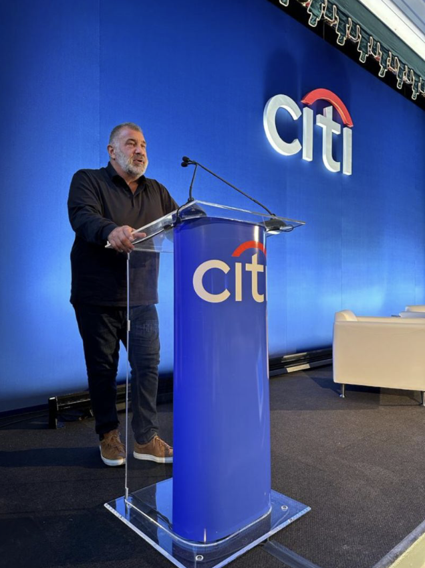

________________________________________________________________

The programme is subject to change.

Date & Time of next branch meeting: Friday 19th January 2024

